**Test Cases**

| Morse code | English |
| --- | --- |
| .--. .-.. . .- ... . / --. .. ...- . / -- . / .- -. / .- | please give me an a |
| .. / .-.. --- ...- . / -.-. --- -.. .. -. --. | i love coding |
| -.-. --- -- .--. ..- - . .-. / ... -.-. .. . -. -.-. . | computer science |
| -- --- .-. ... . / -.-. --- -.. . / .. ... / ... --- / -.-. --- --- .-.. | morse code is so cool |
| .. / .-.. --- ...- . / .--. --- -.- . -- --- -. | I love pokemon |
| .... --- .-- / .- .-. . / -.-- --- ..- | How are you |
| -. .. -.-. . / - --- / -- . . - / -.-- --- ..- | Nice to meet you |
| . -. . .-. --. -.-- / -.. .-. .. -. -.- ... / .- .-. . / ... --- / -.. . .-.. .. -.-. .. --- ..- ... | Energy drinks are so delicious |
| .. / .... .- - . / . -..- .- -- / ... . .- ... --- -. | I hate exam season |
| ... --- / . -..- -.-. .. - . -.. / ..-. --- .-. / ... ..- -- -- . .-. | So excited for summer |

**Screenshots of working in gl**

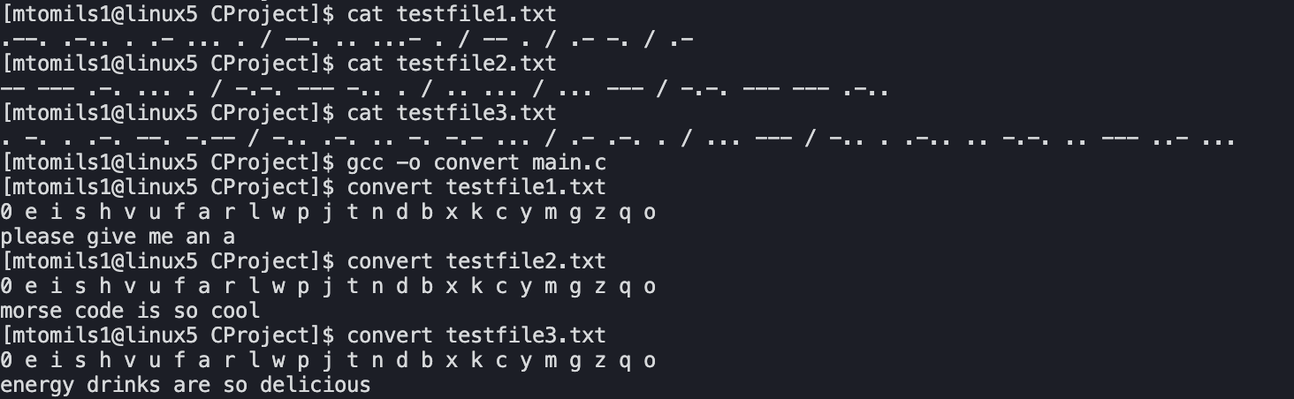

**Pseudocode:**

Function createNode(char character)

Create newNode

Set newNode’s letter to given character

Set newNode’s left and right pointer to null

Return newNode

Function buildMorseTree(node* root)

insertNode(root, morsestring, correspondingLetter) for every alphabet letter

Function insertNode(node* root, const char* morse, char letter)

Node* curr = root;

while(morse index exists) // not at end of morse string

If morse char is ‘.’ traverse left of tree

If left doesnt exist create placeholder node then move curr there

If it does exist, move curr there

If morse char is ‘-’ traverse right of tree

If right doesn’t exist create placeholder node then move curr there

If it does exist, move curr there

Move morse index to next character

After while loop, set curr letter to the given letter

Function convertMorseToEnglish(char* characters, char* output)

Allocate memory for new root

Int index = 0

buildMorseTree(root)

Node* curr = root;

while(characters index exists) // not at end of characters

If morse char is ‘ ‘ check if curr letter is ‘0’

If curr letter is ‘0’ add ‘ ‘ to output then increment index by 1

If curr letter is not ‘0’, add the current letter to output and increment index by 1

Then reset current back to the root

If morse character is ‘/’ add space to output

If morse character is ‘.’ set current to currents right node

If morse character is ‘-’ set current to currents left node

Move characters index to the next character

Free the tree’s memory